

BRITISH COLUMBIA INSTITUTE OF TECHNOLOGY
School of Computing and Academic Studies | Lab#2
Program: Computer Systems Technology | COMP 7615 Cryptographic Methods
Instructor: Dr. Abhijit Sen | Due Date: Sept 28th,2009

- Caeser Cipher : Histogram Analysis of the Caesar’s Cipher

- Get any 3 relatively long ENGLISH texts (each with at least 5,000 letters or more) from Internet. Cite URL of the sources of the texts chosen (USE THE SAME TEXTS AS IN LAB 1):
- In the main menu, open the “Analysis” submenu and select “Tools for Analysis -> Histogram” to obtain the histogram of the plaintexts (un-encrypted) document (Figure 1). Save the result.
- Encrypt each of the plaintext document (English text) using the Caesar cipher.
- In CrypTool click on the window with the plaintext document in order to make it active.
- In the main menu, under the “Crypt/Decrypt” submenus select “Symmetric Classic-> Caesar”.
- Enter any encryption key and encrypt the plaintext documents
- In the main menu, open the “Analysis” submenu and select “Tools for Analysis -> Histogram” to obtain the histogram of the cipher text (encrypted) documents (Figure 2). Save the results.

- Compare the histogram results of each cipher text with the corresponding histogram result of the plaintexts. Describe/explain your observations.

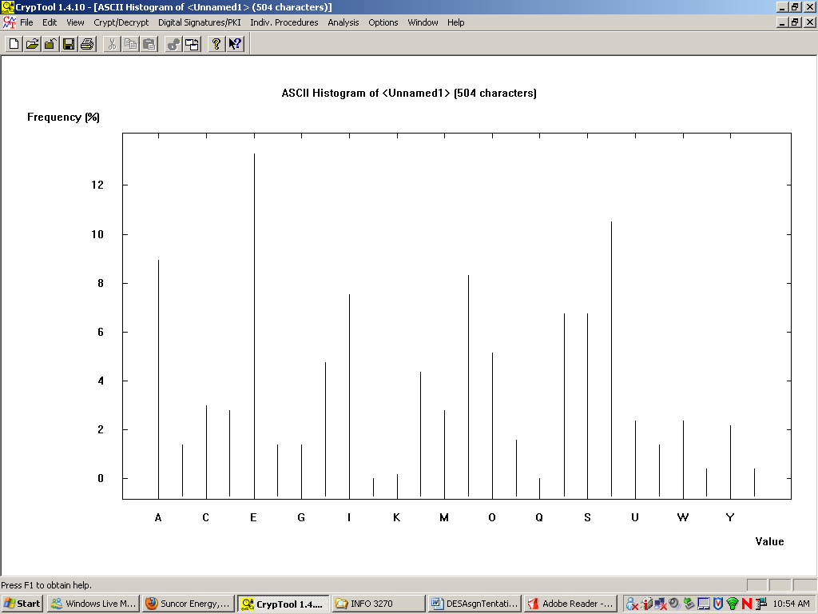

Figure 1: Histogram of a plaintext message (Caesar’s Cipher)

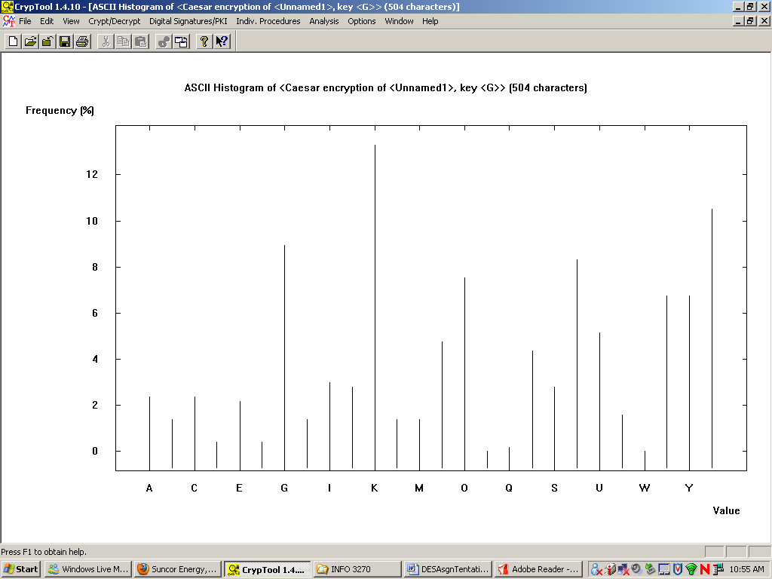

Figure 2: Histogram of a cipher text message (Caesar’s Cipher)

- Submission Requirements:

Please submit the document in the share drive.

  - Submit a professionally formatted report (Word document) containing the following:

- Cover page with your:
  - full name
  - email address
  - student id number
  - Lab #
  - Date of Submission
- Section 1:Purpose:
- Section 2:Procedures: Step by step description of your procedures with Screen Shots
- Section 3:Discussion: Clearly discuss the result and your observations
- Section 4 Conclusion

  - Name the word file as :

Crypto_L2_ Lastname_Initial.doc

